**DAILY ONLINE ACTIVITIES SUMMARY**

|  |  |  |  |  |  |  |  |  |
| --- | --- | --- | --- | --- | --- | --- | --- | --- |
| **Date:** | **11/06/2020** | | | | | **Name:** | **AKASH S** | |
| **Sem & Sec** | **4TH&A** | | | | | **USN:** | **4AL18CS004** | |
| **Online Test Summary** | | | | | | | | |
| **Subject** | | **---------** | | | | | | |
| **Max. Marks** | | **--** | | **Score** | | | **--** | |
| **Certification Course Summary** | | | | | | | | |
| **Course** | **Front end Development-HTML** | | | | | | | |
| **Certificate Provider** | | | **GREAT LEARNING** | | **Duration** | | | **3.5 HOURS** |
| **Coding Challenges** | | | | | | | | |
| **Problem Statement 1: 1.  Write a Java Program to Segregate Even and Odd numbers** | | | | | | | | |
| **Status: executed** | | | | | | | | |
| **Uploaded the report in Github** | | | | | **YES** | | | |
| **If yes Repository name** | | | | | <https://github.com/akashacharya786/lockdown-c-coding>  **https://github.com/akashacharya786/lockdown-java-coding** | | | |
| **Uploaded the report in slack** | | | | | **YES** | | | |

Online Test Summary:

**Online Certification course:**

Name of the course : Front end Development-HTML

Duration: 3.5 hours

Certificate provider: great learning

Snap shot:

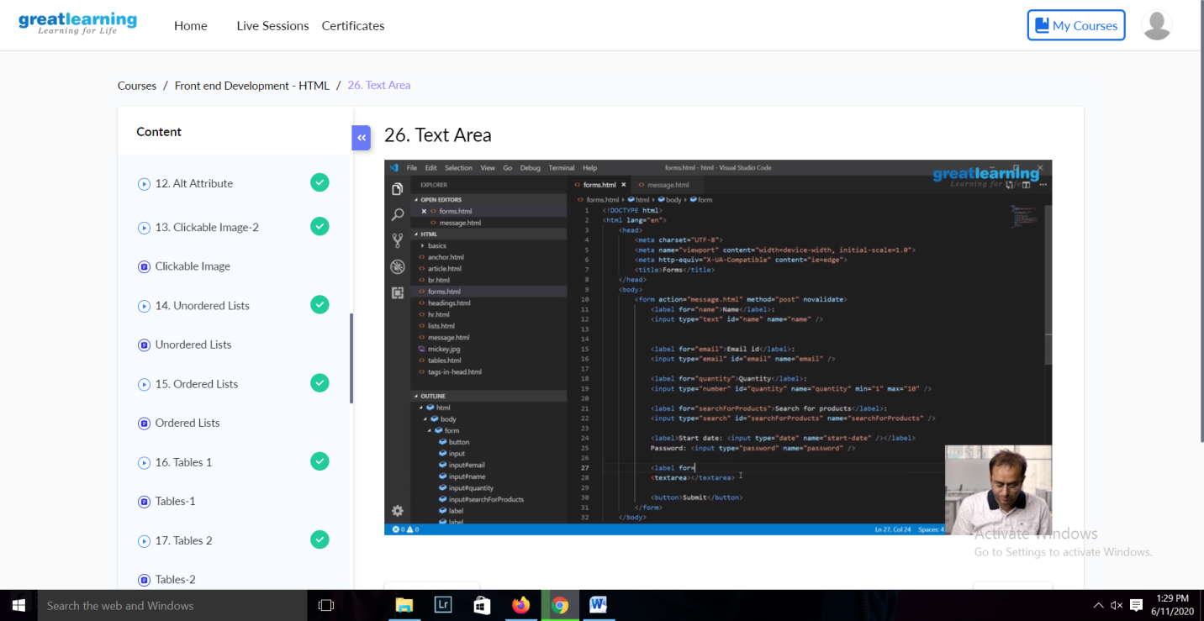

In today ‘s session I learn alt attributes ,lists , how create a tables using html , forms and text area.

Online Coding summary:

**1.  Write a Java Program to Segregate Even and Odd numbers**

